**Level 1: File Handling Definitions**

Use the following resources to answer the questions about file handling in Python.

· <https://www.pythonforbeginners.com/files/reading-and-writing-files-in-python>

· <https://www.pythonforbeginners.com/cheatsheet/python-file-handling>

1. Explain the function of each of the following file handling commands

a. The open() function

The open() function is used to open files in our system, the filename is the

name of the file to be opened.

b. The read() method

The read() method contains different methods, read(),readline() and readlines().

c. The readline() method

The readline() method returns one line at a time. The readlines() method returns a list of lines.

d. The write() method

The write() method writes a sequence of strings to the file.

e. The close() method

The close() method is used when you’re done with a file, use close() to close it and free up any system resources taken up by the open file.

2. Research and explain the “Mode” used to open files in a Python program.

a. ‘r’ mode

"r" is a read mode which is used when the file is only being read.

b. ‘w’ mode

"w" is a write mode which is used to edit and write new information to the file and any existing files with the same name will be erased when this mode is activated.

c. ‘a’ mode

"a" is a appending mode, which is used to add new data to the end of the file which means that new information is automatically amended to the end.

d. ‘r+’ mode

‘r+’ is a special read and write mode which is used to handle both actions when working with a file.

e. Explain when and where the mode is used in a Python program

This tells the Python Program and the program developer which way the file will be used. It is used after the file name.

3. Provide example code which opens a text file for reading and prints the contents of the file to the console display.

a. Explain what each line of the program does.

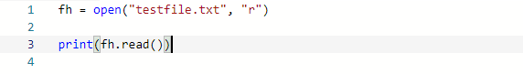

This line first begins with “fh” set as to open the file, the next line simply reads the file to the console.

4. Provide example code which opens a text file for writing and writes some data to the file.

a. Explain what each line of the program does.

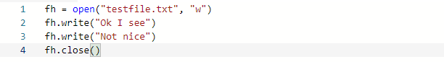

This line first begins with “fh” set as to open the file, the next 2 lines write text into the file and the last line closes the file to free up system resources.

5. Research and explain the difference between a “File Name” (type Python string) and

a File Object (type Python object).

A “File Name” is a python string that is the name of a file while the File Object is an object returned by a call to be opened.

**Level 2: Reading & Writing Files**

1. Add a text file to your project as follows:

· Click on “Add File” icon in the files pane/window.

· Type “myfile.txt” and return.

· “myfile.txt” is now open in the editor pane/window.

· Type some text into “myfile.txt”

· Make sure to add several lines of text. A sample file contents could look like:

*Hello kind student\n*

*This is a message from your computer\n*

*I hope you are having fun learning to program\n*

*Remember to ask Mr. Nestor questions when you don’t understand.*

2. Write a program that opens “myfile.txt” for reading and prints the contents to the file to the console display.

a. The program should also print out the number of lines in the file

b. Provide a listing of your program below

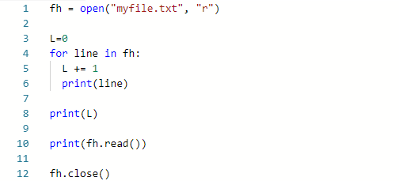

Results:

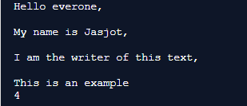

3. Write a program that opens “myfile.txt” for appending new contents to the file.

a. You can “hard code” some commands to write new text to the file

b. Make sure to use the close() method when your are finished.

(What happens if you don’t?)

If we don’t use the close() method when we are finished using the file, then the file can be affected by other files.

c. How can you tell that your program worked? (That the contents changed?)

We can tell that the program worked because the text gets printed and then gets successfully appended with the new text at the end of the program. The changes to the file can be seen on the console.

d. Provide a listing of your program below

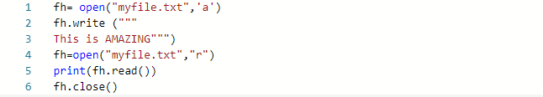

Results:

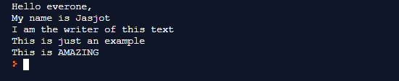

4. Write a program that opens “myfile.txt” for writing new contents to the file.

a. You can “hard code” some commands to write new text to the file

b. Explain the difference between appending and writing to a file.

c. Provide a listing of your program below

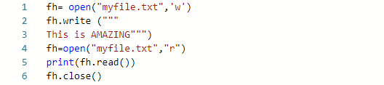

Results:



The difference between appending and writing to a file is that appending adds text to the end of the file’s text while writing completely overwrites it with the new text.

**Level 3: Folders & Binary Files**

1. Add a folder called “resources” to your project as follows:

· Click on “Add Folder” icon in the files pane/window.

· Type “resources” and return.

I have done this.

2. Drag and drop your “myfile.txt” file into the “resources” folder.

I have done this.

3. Run you program from Level 2 to see what happens.

a. Why does it give an error?

It gives an error because there is no file or directory known as “my.file.txt”.

b. How can you modify the file name string used by the open() function so that it also includes the “resources” folder?

We can add a forward slash in the code to create a path to the file.

c. Fix the open() function so that the program runs correctly and provide your program listing below.



Results:

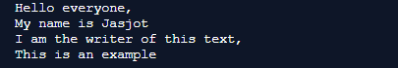

4. Research and explain the “Binary Mode” used to open files in a Python program.

a. What is the ‘rb’ mode and how is it different from the ‘r’ mode

“rb” mode is when the file is opened in binary mode and this means that it is opened in read binary mode.

b. What is the ‘wb’ mode and how is it different from the ‘w’ mode

“wb” mode is when the file is opened in binary mode and this means that it is opened in write binary mode.

5. Add the “Penguin.bmp” binary image file to your repl project as follows:

a. Download the “Penguin.bmp” file from the GitHub repository to your desktop

b. Drag and drop the “Penguin.bmp” from your desktop to the “resources” folder in your repl project

c. Click on the “Penguin.bmp” to make sure everything is ok.

I have done this.

6. Modify your Level 2 program to open the “Penguin.bmp” and print its contents to the screen.

a. Provide a listing of your modified code below



b. Explain what you see as output compared to the penguin image itself

When we run the program, the output appears to be a lot of repeating numbers but the numbers are slightly different each time. This happened because the picture is basically a lot of number instructions on how the image colours should be. This is an example of pixels.